ANOVA
Lee Barnby
2023-10-17

R Markdown
This is an R Markdown document. Markdown is a simple formatting syntax for authoring HTML, PDF, and MS Word documents. For more details on using R Markdown see http://rmarkdown.rstudio.com.
When you click the Knit button a document will be generated that includes both content as well as the output of any embedded R code chunks within the document.
You can remove the above and write your own notes.

Hospital Stay example
We start with the example used in the lecture, a set of data from three anonymised hosptials (A,B,C). We will need to store the data and arrange into a data frame, with suitable names for the columns.
A <- c(100,134,132,125,121,144,110,133,113,145)
B <- c(120,154,152,150,141,161,131,160,132,154)
C <- c(130,160,161,157,151,170,140,165,142,162)
HospStay <- data.frame( c(A,B,C), c(rep("A",10),rep("B",10),rep("C",10)) )
names(HospStay) <- c("StayLength","Hospital")
summary(HospStay)
## StayLength Hospital
## Min. :100.0 Length:30
## 1st Qu.:131.2 Class :character
## Median :143.0 Mode :character
## Mean :141.7
## 3rd Qu.:156.2
## Max. :170.0
We can make a visual examination of the data with a ‘boxplot’. This is just a basic version, a google search will reveal tutorials on many more attractive visualisations e.g. https://www.statmethods.net/graphs/boxplot.html
boxplot(HospStay$StayLength ~ HospStay$Hospital)
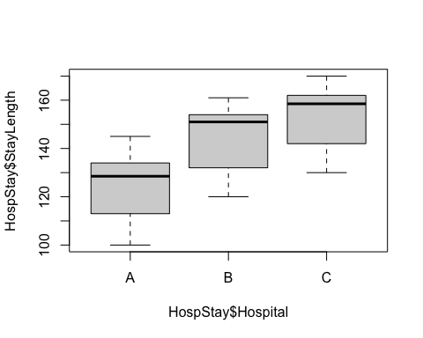 We might suspect from this that hospital A has a different mean but we need a way to quantify this.
oneway.test(HospStay$StayLength ~ HospStay$Hospital)
##
## One-way analysis of means (not assuming equal variances)
##
## data: HospStay$StayLength and HospStay$Hospital
## F = 10.25, num df = 2.000, denom df = 17.934, p-value = 0.001076
We get a simliar result to our ‘by-hand’ calculation performed in the lecture but it is not identical. The value of the F-statstic is rather close, the p-value is notably smaller, which doesn’t affect anything as it was already very small. The degrees of freedom are calculate and reported but this shows that the denominator degree of freedom is not 27 and is even not a whole number! The explanation lies in the information: “(not assuming equal variances)”. The default implementation relaxes this assumption and does a more sophisticated caclulation.
In fact we can enforce the assumption with an option
oneway.test(HospStay$StayLength ~ HospStay$Hospital, var.equal = TRUE)
##
## One-way analysis of means
##
## data: HospStay$StayLength and HospStay$Hospital
## F = 10.948, num df = 2, denom df = 27, p-value = 0.0003298
Now we recover the simple version of the calculation. There is no difference to the outcome. In both cases the p-value is very small and you should reject the null hypothesis of the three samples being drawn from a population with a common mean.
You would have to be rather unluckly to come across a real life example in which this matters e.g. one p-value slightly below 0.05 and the other slightly above.
You can actually test for equal variance using the Bartlett test. This tests the null hypothesis that the samples are drawn from a population with a common variance.
bartlett.test(HospStay$StayLength ~ HospStay$Hospital)
##
## Bartlett test of homogeneity of variances
##
## data: HospStay$StayLength by HospStay$Hospital
## Bartlett's K-squared = 0.18582, df = 2, p-value = 0.9113
Here we would conclude that there is no evidence to reject the null hypothesis since p is quite large at over 0.9. We could then decide that it is OK to assume equal variances.
While considering assumptions we might also want to test the assumption that the data are normally distributed using qqplot, qqline or the Shapiro-Wilk test.
(you can continue your study below with new code chunks and text blocks)

